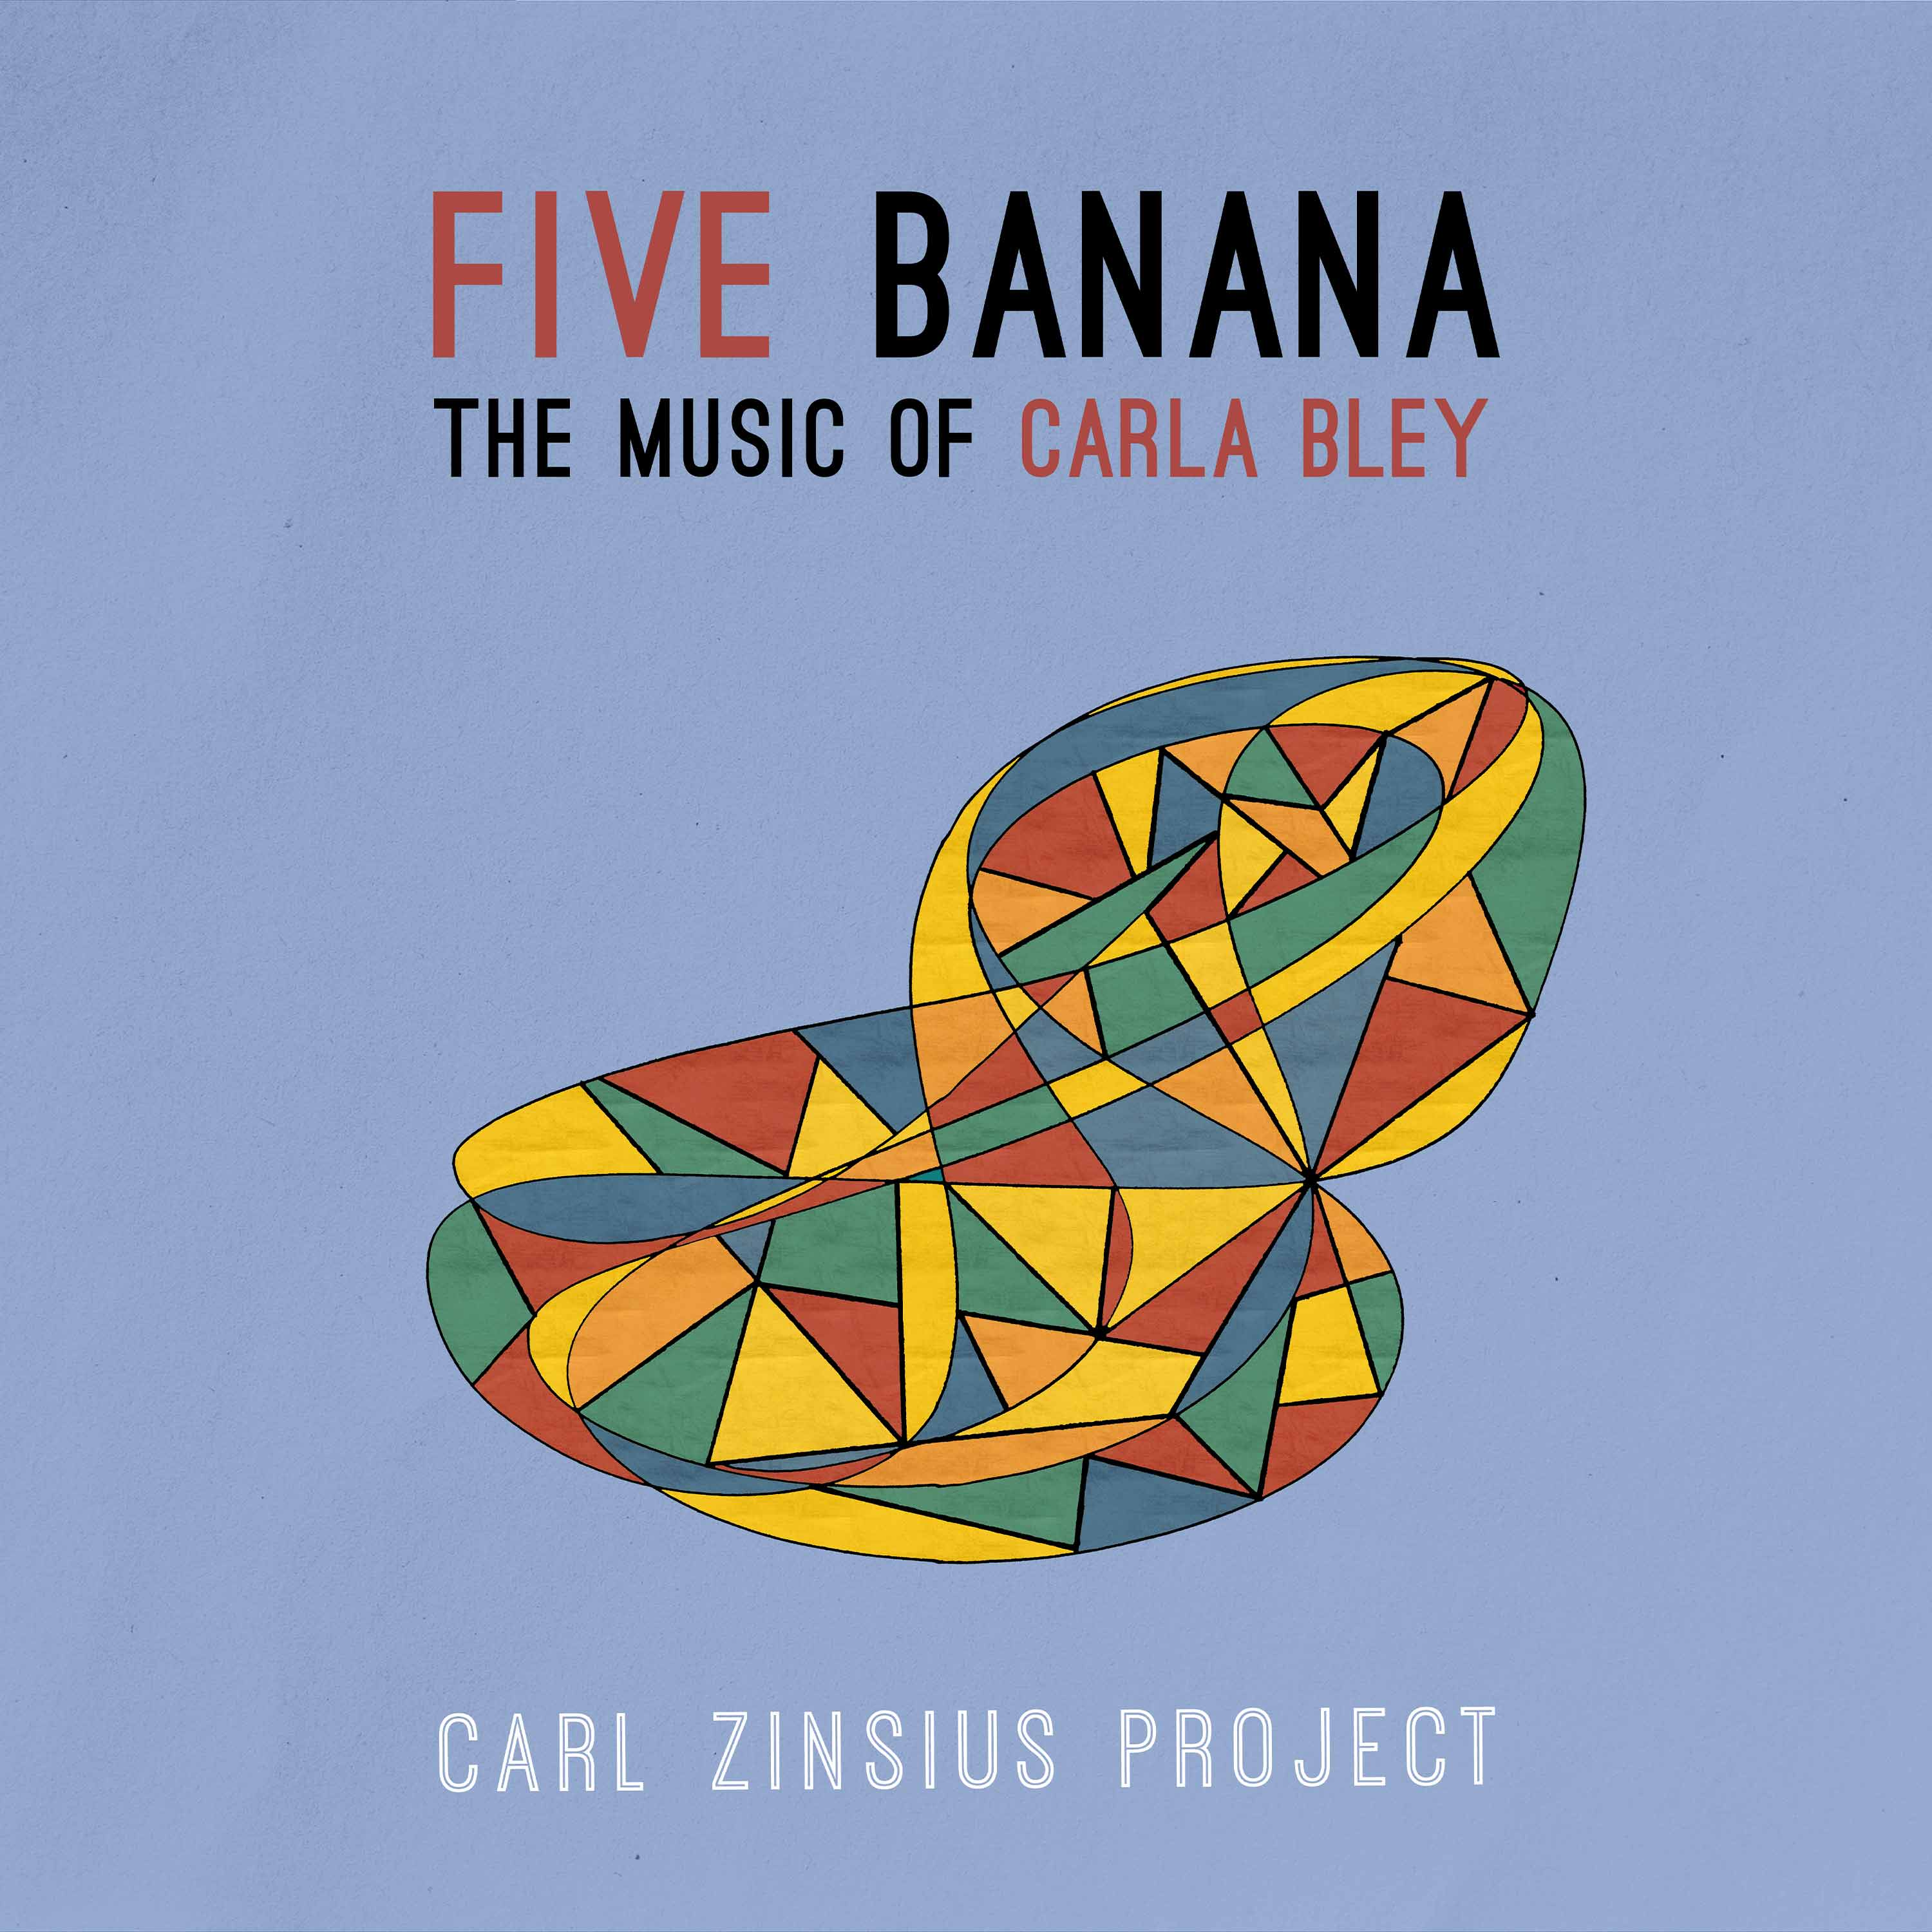
FIVE BANANA – THE MUSIC OF CARLA BLEY (Carl Zinsius Project)
The Carl Zinsius Project is a chamber ensemble, improvisation collective and groove machine all in one. And plays its very own version of European jazz in the 21st century.
In spring 2024, the ensemble will present its debut album "Five Banana - The music of Carla Bley".
On this album, the five musicians interpret the repertoire of composer Carla Bley with great curiosity, enthusiasm and open ears.
The US-American Bley, who died in October 2023, is certainly one of the most important jazz composers of our time. Bley wrote pieces for the pianist & her first husband Paul Bley as early as the 1960s and thus became part of the avant-garde jazz movement. As conductor & arranger for Charlie Haden's "Liberation Music Orchestra", composer of the jazz opera "Escalator Over The Hill", founder of her own label and leading woman in a male domain, Bley has always been an unrivalled role model.
On "Five Banana", strange & humorous compositions meet beautiful, simple yet surprising melodies and give an insight into the work of this unique composer.
A programme between jazz, avant-garde and gospel with the typical Bley wink.
Video Bandcamp Spotify
Band:
Alex Scott – Saxophone | Anais Pasanau Miró – Clarinet/Saxophone
Willem Suilen – Piano | Conrad Noll – Bass | Carl Zinsius – Drums
Germany-Release Tour:
22.02. Cavete Marburg | 23.02. Kalkwerk Diez (Lahn) | 03.03. Jazz im Büdchen Köln 04.03. Tongelage Essen | 07.03. King Georg Köln | 08.03. Kunsthaus Troisdorf
Contact:
Carl Zinsius | mail@carl-zinsius.de | +49 15738363470 | carl-zinsius.de

